SIGN LANGUAGE RECOGNITION SYSTEM BASED ON CONVOLUTIONAL NEURAL NETWORKS (CNNS)
Conclusion, Future Scope and References
Department of Computer Science and Engineering, TKR College of Engineering & Technology
Batch A16 (CSE-A) · Academic year [ACADEMIC YEAR]
Table 1: Project team
S.No. | Student name | Roll number
1 | AJAY | 24K95A0502
2 | A NAVADEEP REDDDY | 23K91A0514
3 | B MANIDEEP | 23K91A0540
4 | B MAHESHWARI | 23K91A0536

Project guide: V. PALLAVI
Chapter and section numbers quoted in the text (for example Chapter 8 or Section 6.2) refer to the full project report, 17.Final Document. Figures and tables in this document are numbered from 1.

1. CONCLUSION

1.1 Summary
SignSpeak is a working sign language recognition system for the ASL manual alphabet. A browser camera feeds frames to a FastAPI service that crops a hand region, segments it with Otsu's method, resizes it to 64x64 and classifies it with a three-block CNN of 2,199,453 parameters. A temporal rule (confidence 0.75, majority of 15, 18 stable frames) decides when a letter is typed; the letters form a sentence that can be spoken. The application also collects images, trains models and shows their performance. It runs on one CPU-only PC.

1.2 Objectives achieved
Of the six objectives, three were met (preprocessing with segmentation and augmentation, a trained CNN, text and speech output) and three were met in part: the dataset covers the alphabet and control signs but not common words; real-time operation is achieved at about 17.6 frames per second on a CPU without model optimisation; and evaluation covers accuracy, per-class performance and latency but not unseen signers. Chapter 8 gives the table.

1.3 Key findings
1. A compact CNN on a 64x64 Otsu mask reads held-out frames of the dataset with 82.81% accuracy (macro F1 0.830, top-3 92.9%).
2. Confidence is informative: at the 0.75 threshold the system accepts 70.3% of frames and is right on 97.1% of them, so rejecting low-confidence frames is an effective filter.
3. Errors concentrate in look-alike signs (V with W and U, E with B and A, S with Y) and in rotated or brighter images (accuracy 85.0 % falls to about 68 % at +/-10 degrees of rotation).
4. The system is fast enough to be used live on a CPU: 52.9 ms per frame on the server, 17.6 frames per second end to end; the CNN call is 95 % of the server time.
5. Numbers measured on a random split of video frames are optimistic: other photos of the same archive score 87.24 %, but near-duplicate frames explain part of that, so the held-out 82.81 % is the figure we report.
6. A single code path for desktop and web, backed by 52 tests, made it possible to rebuild the interface without touching the recognition logic.

1.4 Practical applications
• A fingerspelling aid for a signer to spell a name or a technical term to a hearing person, with the sentence shown and spoken.
• A teaching tool for learners of the ASL alphabet, who can check whether a hand shape is read as intended.
• A platform for building personal or local-variant models: the Collect and Train screens let a user capture their own hands and retrain.
• A base for classroom exercises on the whole machine-learning cycle: data, preprocessing, training, evaluation and deployment.

1.5 Known limitations
The system recognises letters only, was evaluated on held-out frames of the same recordings as the training set and not on unseen signers, is sensitive to rotation and cluttered backgrounds, was tested end to end with a fake camera, has no authentication, and has had no user study. It is a research and teaching prototype, not a certified assistive device. Section 8.8 and the limitation table of the scope document give the full list.
The per-class results behind the key findings are shown below, together with the confidence trade-off of the decision rule.
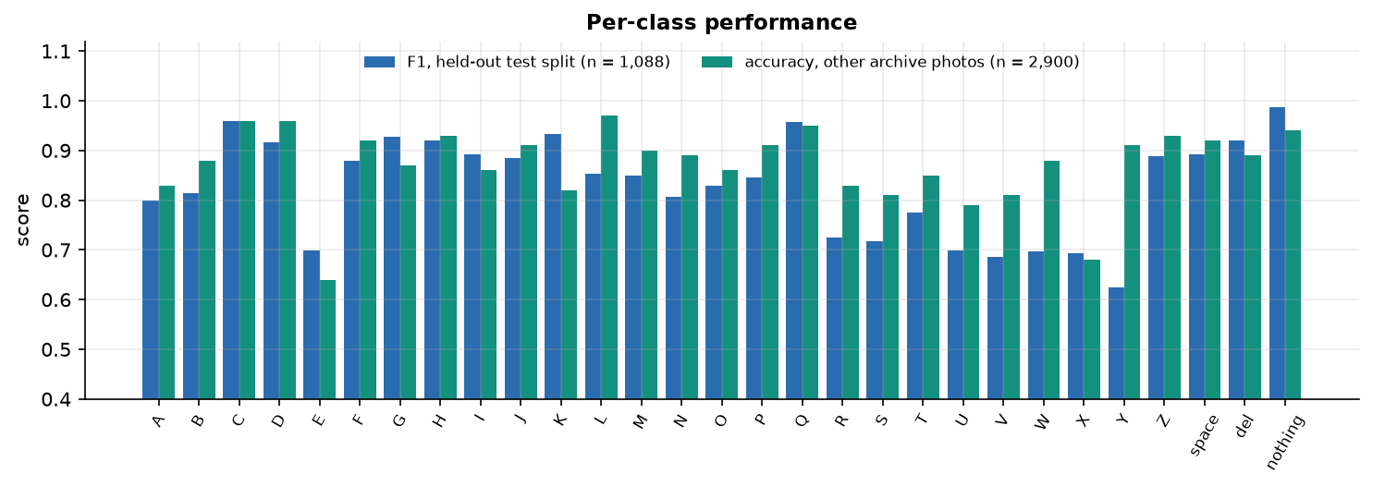
Figure 1: F1 of each class on the test split, beside accuracy on other archive photos (optimistic).
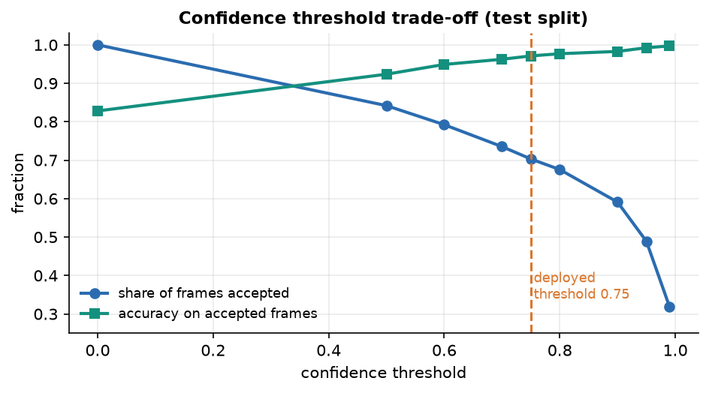
Figure 2: Frames accepted and accuracy on accepted frames against the confidence threshold.

2. FUTURE SCOPE

2.1 Improvements to the recogniser
• Unseen-signer evaluation first. Record several signers in several rooms (or use a dataset with signer identifiers), split by signer, and report that accuracy as the headline; this is the most important missing measurement.
• More data and a proper search. Use more than 250 images per class, longer runs and a small hyper-parameter search; add ablations of the preprocessing (Otsu against skin mask against none) and of the dropout rates.
• Better hand isolation. Replace Otsu by a hand-landmark detector such as MediaPipe [13] and classify the landmarks (or crop around them), which would remove most background structure and bring SignSpeak closer to the skeleton idea of the base paper [1].
• Orientation robustness. Rotation-aware augmentation beyond 12 degrees, or normalising the hand's orientation, to address the drop to about 68 % at 10 degrees of tilt.
• Calibrated confidence. Temperature scaling so that a confidence of 0.8 means about 80 % right, and a per-user threshold.

2.2 Additional features
• Words and phrases. A sequence model over landmarks or frames (for example a small temporal CNN or a graph network) trained on a word-level dataset such as WLASL [15] or AUTSL [14], with a vocabulary beyond the alphabet.
• Motion letters. Recognise J and Z from a short window of frames instead of one frame.
• Two-way communication. Add speech-to-text so that a hearing person's reply is shown to the signer.
• Personalisation. A short calibration that fine-tunes the model on a new user's hand in a minute.
• Languages and voices. Other sign alphabets and text-to-speech voices.

2.3 Scalability and deployment
• Faster inference. Call the model directly instead of model.predict, export to a lighter runtime and quantise; the 50 ms CNN call is the main cost. Running the model in the browser (for example with TensorFlow.js) would remove the server round trip.
• Edge devices. Port to a phone or a Jetson-class board; the base paper's ONNX and TensorRT workflow [1] is a template, and its power and speed profiling would give a fair comparison of hardware cost.
• Packaging and sharing. Container image, authentication and restricted origins before any network use; a persistent session store if several users are to share one server.
• Continuous evaluation. Run the measurement script and the 52 tests in a CI pipeline so that every model change is evaluated automatically.

2.4 Further research
• Apply knowledge distillation, the base paper's technique [12], [1], to compress a stronger teacher into the small student used here, and measure the accuracy-latency trade-off on the same held-out and unseen-signer data.
• Study how much of the accuracy comes from the hand and how much from the scene by training on masks with the background removed.
• Run a user study with deaf and hearing participants to measure typing speed, error rate and acceptance.

3. REFERENCES
[1] D. T. D. Vo, V. D. Nguyen, T. H. M. Nguyen and M. H. Vo, "MAG-KD: Mask-guided adaptive gating knowledge distillation for skeleton-based sign language recognition on edge devices," IEEE Access, vol. 14, pp. 54761-54775, 2026, doi: 10.1109/ACCESS.2026.3681176.
[2] B. A. Al Abdullah, G. A. Amoudi and H. S. Alghamdi, "Advancements in sign language recognition: A comprehensive review and future prospects," IEEE Access, vol. 12, pp. 128871-128895, 2024.
[3] R. Rastgoo, K. Kiani and S. Escalera, "Sign language recognition: A deep survey," Expert Syst. Appl., vol. 164, Art. no. 113794, Feb. 2021.
[4] T. Starner, J. Weaver and A. Pentland, "Real-time American Sign Language recognition using desk and wearable computer based video," IEEE Trans. Pattern Anal. Mach. Intell., vol. 20, no. 12, pp. 1371-1375, Dec. 1998.
[5] N. Pugeault and R. Bowden, "Spelling it out: Real-time ASL fingerspelling recognition," in Proc. IEEE Int. Conf. Comput. Vis. Workshops (ICCV Workshops), Barcelona, Spain, Nov. 2011, pp. 1114-1119.
[6] V. Bheda and D. Radpour, "Using deep convolutional networks for gesture recognition in American Sign Language," 2017, arXiv:1710.06836.
[7] Y. LeCun, L. Bottou, Y. Bengio and P. Haffner, "Gradient-based learning applied to document recognition," Proc. IEEE, vol. 86, no. 11, pp. 2278-2324, Nov. 1998.
[8] A. Krizhevsky, I. Sutskever and G. E. Hinton, "ImageNet classification with deep convolutional neural networks," Commun. ACM, vol. 60, no. 6, pp. 84-90, May 2017.
[9] D. Tran, L. Bourdev, R. Fergus, L. Torresani and M. Paluri, "Learning spatiotemporal features with 3D convolutional networks," in Proc. IEEE Int. Conf. Comput. Vis. (ICCV), Dec. 2015, pp. 4489-4497.
[10] J. Carreira and A. Zisserman, "Quo vadis, action recognition? A new model and the Kinetics dataset," in Proc. IEEE Conf. Comput. Vis. Pattern Recognit. (CVPR), Jul. 2017, pp. 4724-4733.
[11] S. Yan, Y. Xiong and D. Lin, "Spatial temporal graph convolutional networks for skeleton-based action recognition," in Proc. AAAI Conf. Artif. Intell., vol. 32, no. 1, 2018.
[12] G. Hinton, O. Vinyals and J. Dean, "Distilling the knowledge in a neural network," 2015, arXiv:1503.02531.
[13] C. Lugaresi et al., "MediaPipe: A framework for building perception pipelines," 2019, arXiv:1906.08172.
[14] O. M. Sincan and H. Y. Keles, "AUTSL: A large scale multi-modal Turkish Sign Language dataset and baseline methods," IEEE Access, vol. 8, pp. 181340-181355, 2020.
[15] D. Li, C. R. Opazo, X. Yu and H. Li, "Word-level deep sign language recognition from video: A new large-scale dataset and methods comparison," in Proc. IEEE Winter Conf. Appl. Comput. Vis. (WACV), Mar. 2020, pp. 1448-1458.
[16] N. C. Camgoz, S. Hadfield, O. Koller, H. Ney and R. Bowden, "Neural sign language translation," in Proc. IEEE/CVF Conf. Comput. Vis. Pattern Recognit. (CVPR), Jun. 2018, pp. 7784-7793.
[17] N. Otsu, "A threshold selection method from gray-level histograms," IEEE Trans. Syst., Man, Cybern., vol. SMC-9, no. 1, pp. 62-66, Jan. 1979.
[18] R. C. Gonzalez and R. E. Woods, Digital Image Processing, 4th ed. New York, NY, USA: Pearson, 2018.
[19] S. Ioffe and C. Szegedy, "Batch normalization: Accelerating deep network training by reducing internal covariate shift," in Proc. 32nd Int. Conf. Mach. Learn. (ICML), 2015, pp. 448-456.
[20] N. Srivastava, G. Hinton, A. Krizhevsky, I. Sutskever and R. Salakhutdinov, "Dropout: A simple way to prevent neural networks from overfitting," J. Mach. Learn. Res., vol. 15, no. 56, pp. 1929-1958, 2014.
[21] D. P. Kingma and J. Ba, "Adam: A method for stochastic optimization," in Proc. Int. Conf. Learn. Represent. (ICLR), 2015, arXiv:1412.6980.
[22] C. Shorten and T. M. Khoshgoftaar, "A survey on image data augmentation for deep learning," J. Big Data, vol. 6, Art. no. 60, 2019.
[23] M. Abadi et al., "TensorFlow: A system for large-scale machine learning," in Proc. 12th USENIX Symp. Oper. Syst. Design Implement. (OSDI), 2016, pp. 265-283.
[24] G. Bradski, "The OpenCV library," Dr. Dobb's J. Softw. Tools, 2000.
[25] Akash, "ASL Alphabet," Kaggle dataset (grassknoted/asl-alphabet). [Online]. Available: https://www.kaggle.com/datasets/grassknoted/asl-alphabet (accessed Oct. 2026).
[26] F. Chollet et al., "Keras," 2015. [Online]. Available: https://keras.io
[27] S. Ramirez, "FastAPI." [Online]. Available: https://fastapi.tiangolo.com (accessed Oct. 2026).
[28] "Sign language recognition," in Sign Language Processing, 2024. (Listed in the project literature survey; authors not recorded there and not verified.)
[29] "Gesture recognition for sign language with AI," 2024. (Listed in the project literature survey; authors and venue not recorded there and not verified.)
[30] "Implementation of a dynamic gesture recognition based Indian Sign Language," i-manager's J. Pattern Recognit., 2024. (Listed in the project literature survey; authors not recorded there and not verified.)
[31] "Translation independent gesture recognition system for multilingual sign language," 2025. (Listed in the project literature survey; authors and venue not recorded there and not verified.)

